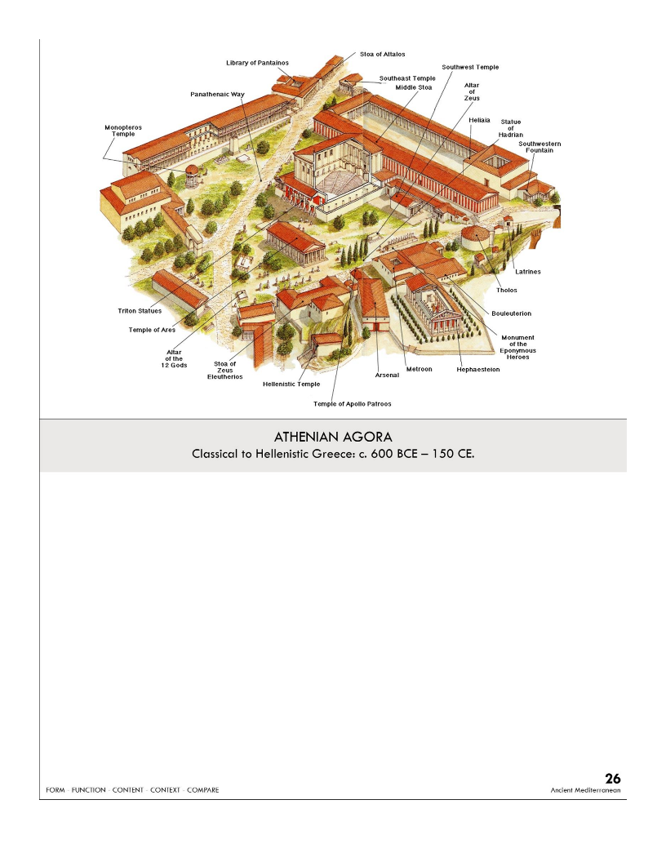

| **Form:**  made out of marble and stone, open space, Panathenaic Way goes through the center of the city leads to the acropolis  **Function:**  Setting for the Panathenaic festival held every 4 years. Place of community, dedicated to Athena  **Content:**  surrounded by bulitaria council chamber of citizens, Stoas, many temples were a market school and civic center would be( Agora). The Stoa → business, political discussions, civic life  **Context:**  at base of the acropolis. Was invaded by the Persians but rebuilt in the early Common Era  500 BCE → citizens start to be able to participate more in the government  Didn’t vote → participated directly, Offices held by rotation  Positions that were voted on required skills (like generals)  **Compare:** tradijens forem of rome  **26**  Ancient Mediterranean |
| --- |

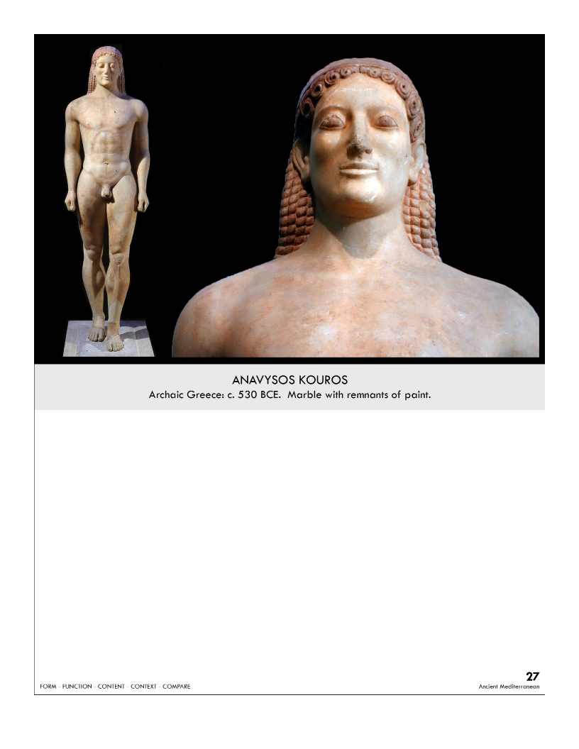

| **Form:**  6’4” tall made of marble. Life-sized image of an idealized human being( warrior). Egyptian style stance  **Function:**  kouros was very popular in ancient Athens. grave marker for aristocrats  **Content:**  very realistic(body shape) and not stylized. A lot of detail in the body. Standing straight and tall. Weight is distributed very realistically. Stylized hair. Naturalistic figure.  **Context:**  Made in Athens. Originally painted. Buried underground in Grease. Bodies and warriors were very important- said that a beautiful body is a gift/blessing from the gods. similar to Egyptian style movement  **Compare:**    **27**  Ancient Mediterranean |
| --- |

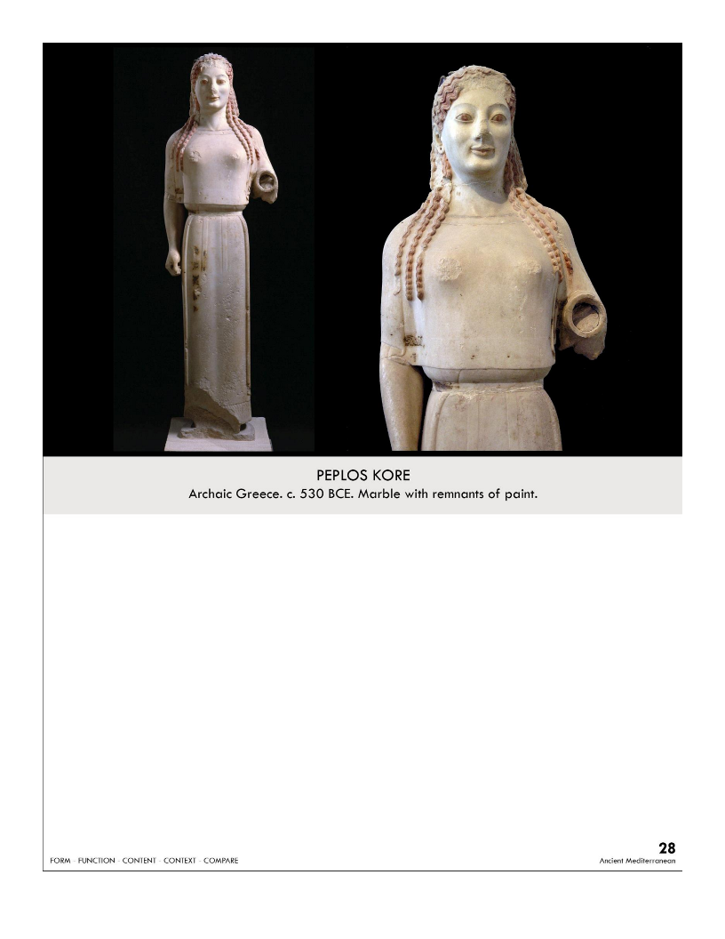

| **Form:**  4’ high made of marble. Brightly pigmented paint. Fine-grained Parian marble (white). Missing left arm. Round natural face    **Function:**  Unknown but guess: To honor and depict a Greek goddess (likely Artemis) Place holder for the altar in Greek temple, Grave marker  **Content:**  wearing a chiton. Arm extended with the intent of holding something. Kora statute(young maiden)  **Context:**  from Acropolis (ancient citadel on a hill) at Athens, Greece. Artist unknown  **Compare:**  **28**  Ancient Mediterranean |
| --- |

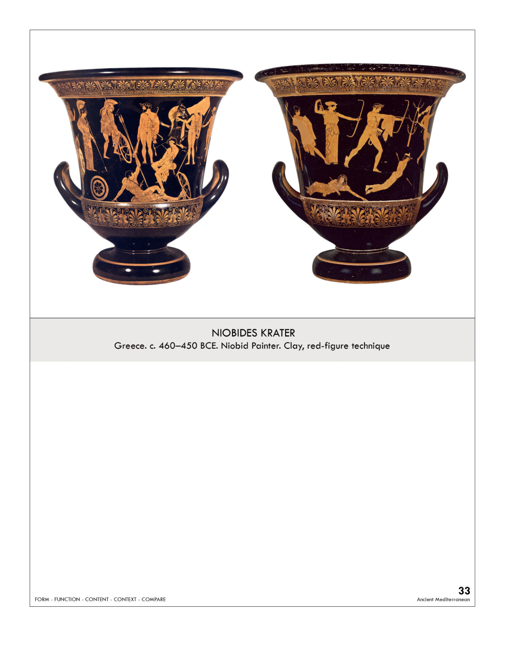

| **Form:**  high classical: without registers base terracotta red figure-ground calyx krater  **Function:**  holding wine or food, high status, aros  **Content:**  shows the body from many directions, naturalism, contorting bodies, Apollo, and Artemis shooting people. Rocky outcropping. done realistically  **Context:**  speaks of statues. Niobe goddess was jealous/ talked bad about Lito so Lito sent 2 children (Apollo and Artemis) to kill all her sons and daughters, showing a slaughter. Becomes more realistic and less stylized. Archaic period  **Compare:**  **33**  Ancient Mediterranean |
| --- |

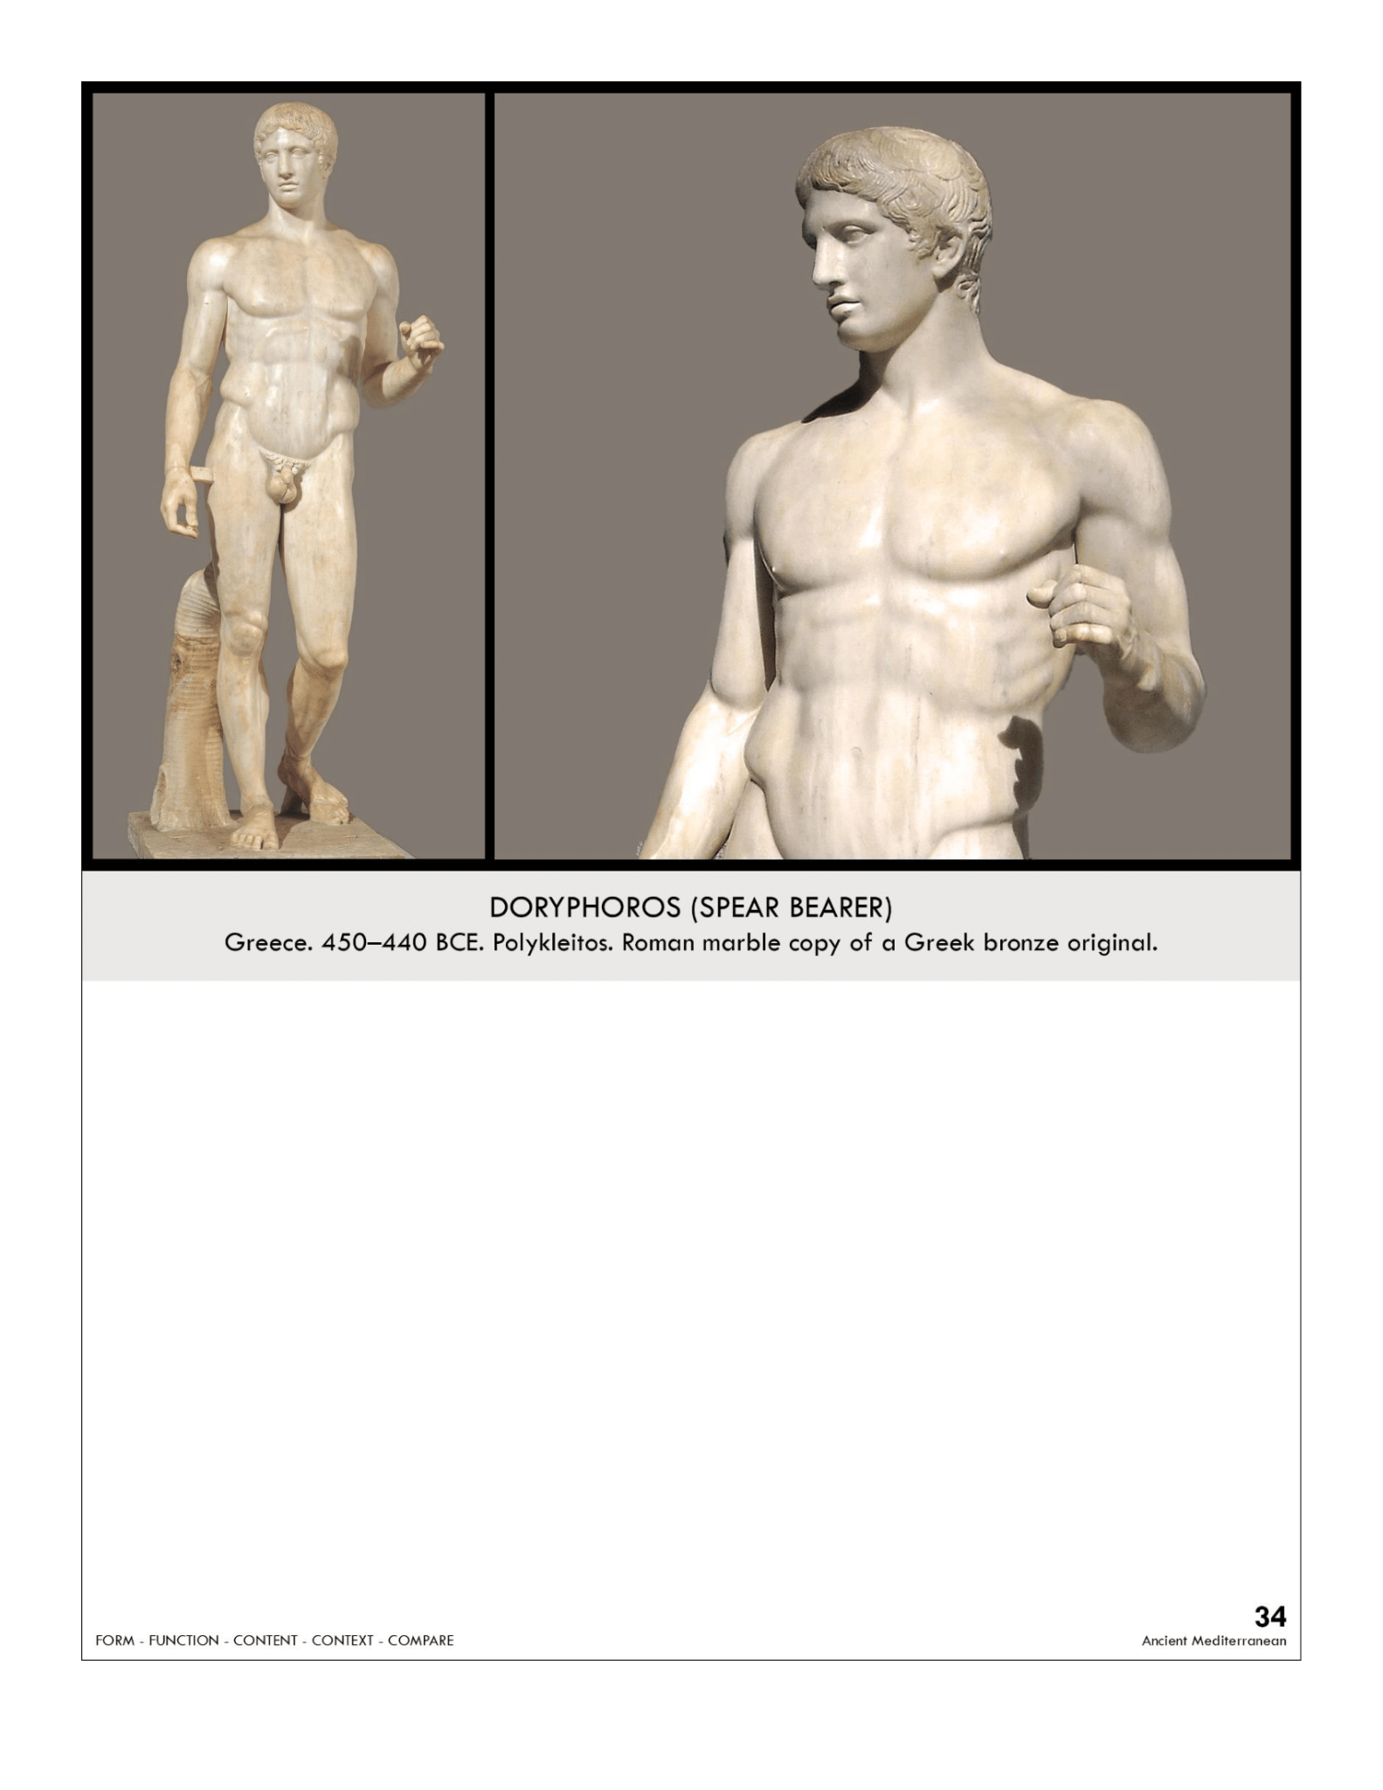

| **Form:**  Marble 6’11” tall, freestanding  **Function:**  sculpture of an athlete to inspire young men to become better athletes. Statue for a gym. Demonstration of ideal/ perfect body  **Content:**  naked = celebrates the natural human body, its beauty, and its strength marks this as a Greek sculpture, one of the earliest examples of contrapposto, includes a strong sense of harmony and counterbalancing:  left arm and right leg = relaxed right arm and left leg = tensed. body divided into 4 quarters  **Context**:  perfect body in the most perfect pose. Greek naturalistic, canon of Greek proportions, Greek symmetry. Very mathematical head 1/9th of the body. Bodies were very. Found in a palestra (a place for athletes to work out in) in Pompeii one of the most copied Greek sculptures  **Compare:** Michelangelo **later works...**  **34**  Ancient Mediterranean |
| --- |

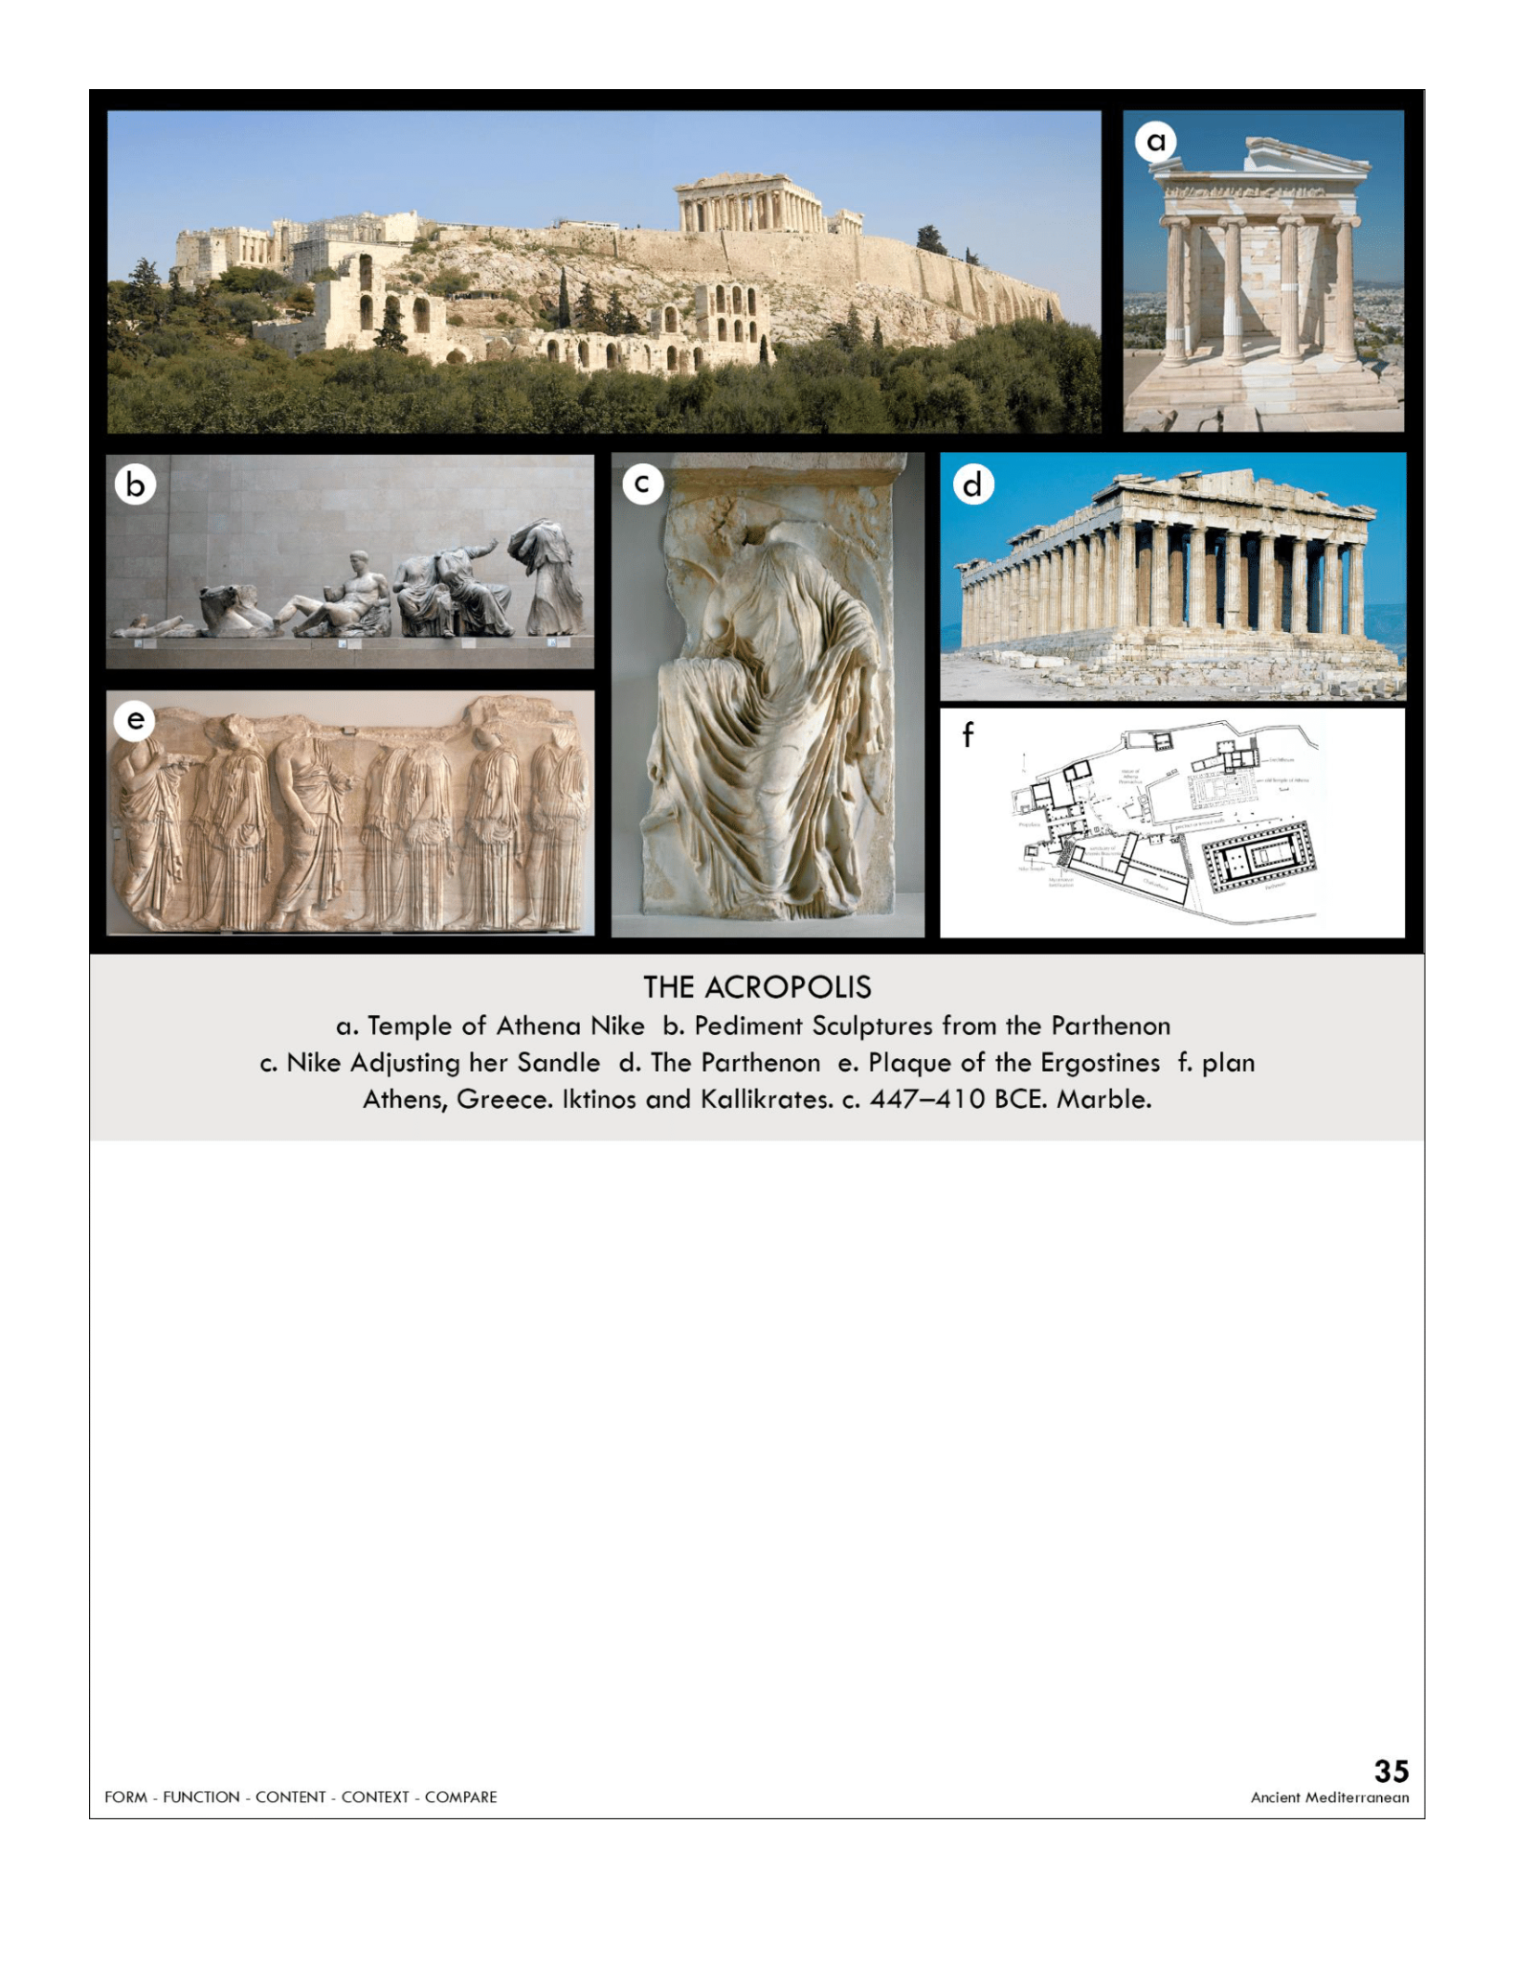

| **Form:**  Parthenon: perfect Doric order, Mathematically integrated perfectly proportioned ratio 9:4  **Function:**  Parthenon: dedicated to Athena Athens patron Goddess, also a treasury  **Content:**  Parthenon: columns and the base curve. Mathematically expresses the golden mean. 32 metopes( sack of troy) and centauromachy (32 metopes) - shows depth and realism, expresses real life.  **Context:**  Parthenon: built by Iktinos and Kallikrates. Built from 447-438, Phidias is a sculpture in charge of Athena sculpture, Phidean sculpture. Unlike any other art, it shows work from life, not stylized.  Panathenaic festival: The subject of this freeze is controversial: the parade of civic pride. Phidian drapery ( in charge of this Phidias) shows perspective. In the end, Gods are watching them. a peplos garment  Nike: Goddess of wind adjusting her sandals drapery very elegant  **Compare:**  **35**  Ancient Mediterranean |
| --- |

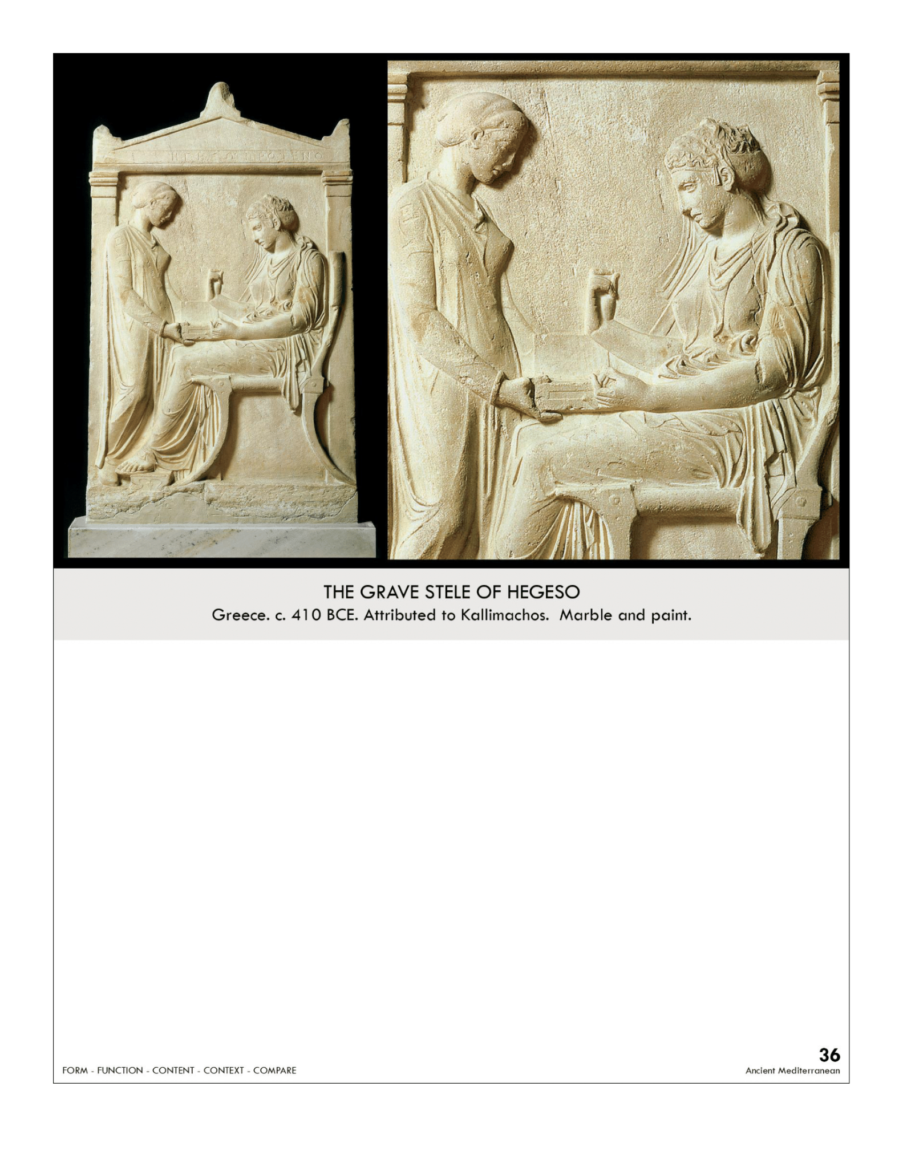

| **Form:**  bai relief sculpture  **Function:**  grave markers,funerary markers private sculpture  **Content:**  decorated with relief sculptures. Shows a servant/slave girl opening a jewelry box and hedges looking at it. Foot on a footrest no part on the ground. Shows full width of the body  **Context:**  410 BCE, found in a cemetery just outside of city gates in Athens. The high classical period after the Parthenon and Phidias. Reamping of the gravestone  **Compare:**  Parthenon, drapery. Anthopalic(warrior) stele  **36**  Ancient Mediterranean |
| --- |

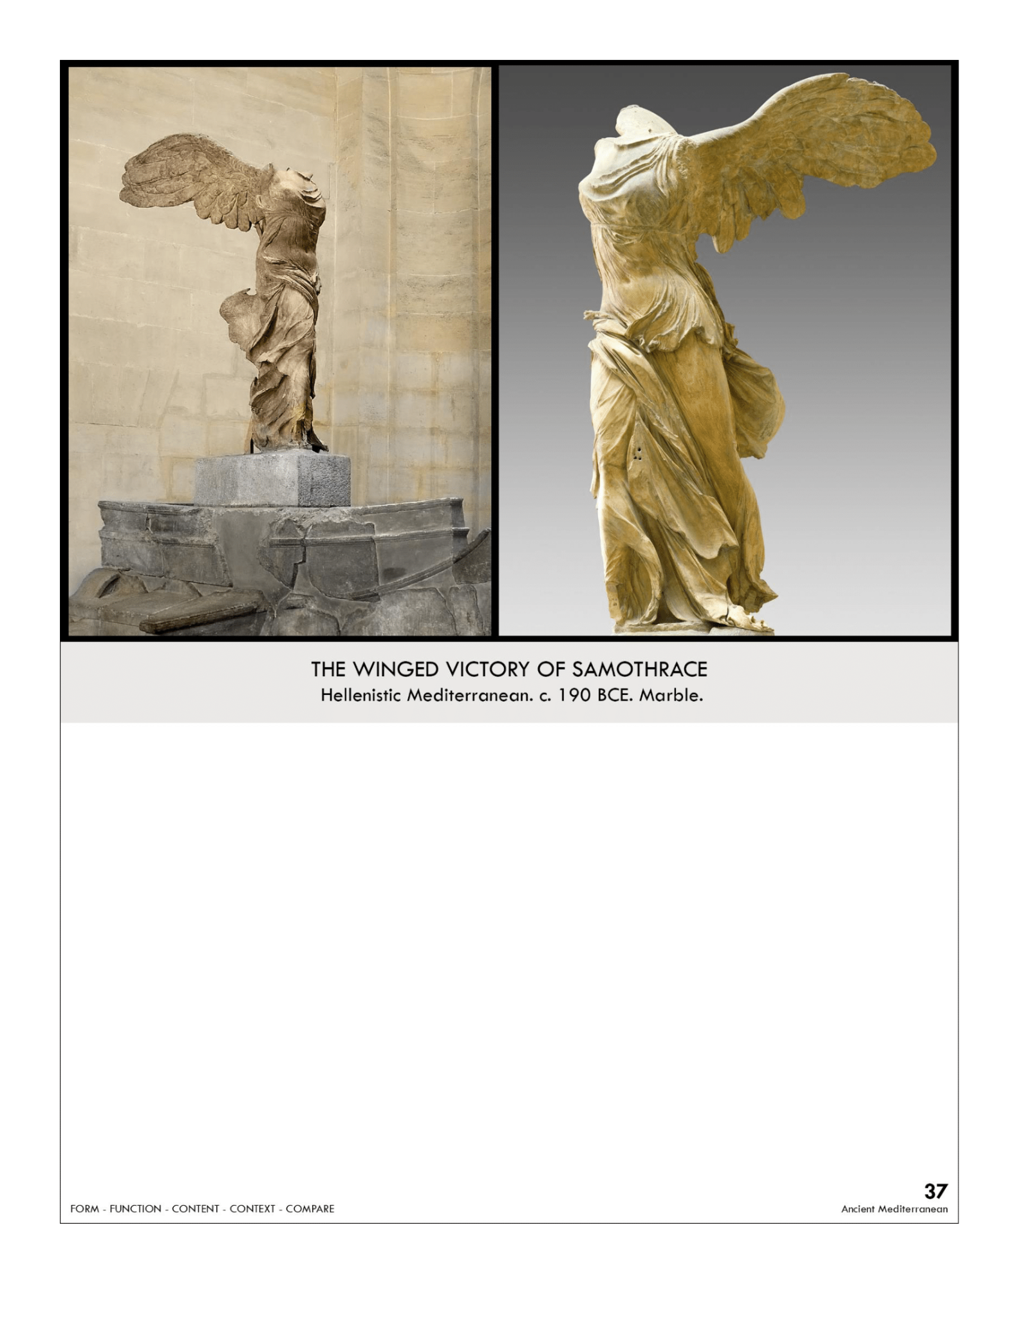

| **Form:** Marble 8 feet tall, over life-sized.  **Function:** to commemorate a naval victory in 190 BCE  **Content:** Phidian drapery idea, since of external environment, swirling statue, drama and movement . depicts Nike, who was the messenger goddess of victory, missing her head and both arms, but may have been holding a trumpet or cupping her hand around her mouth to announce a naval victory on a fountain.  **Context:** goddess of victory(Nike) landing on the fountain. Found in citue in Samothrace . Hellenistic period, the sculptor is unknown  the Hellenistic period followed the death of Alexander the Great when the Greek kingdom got split up  **Compare:**  **37**  Ancient Mediterranean |
| --- |

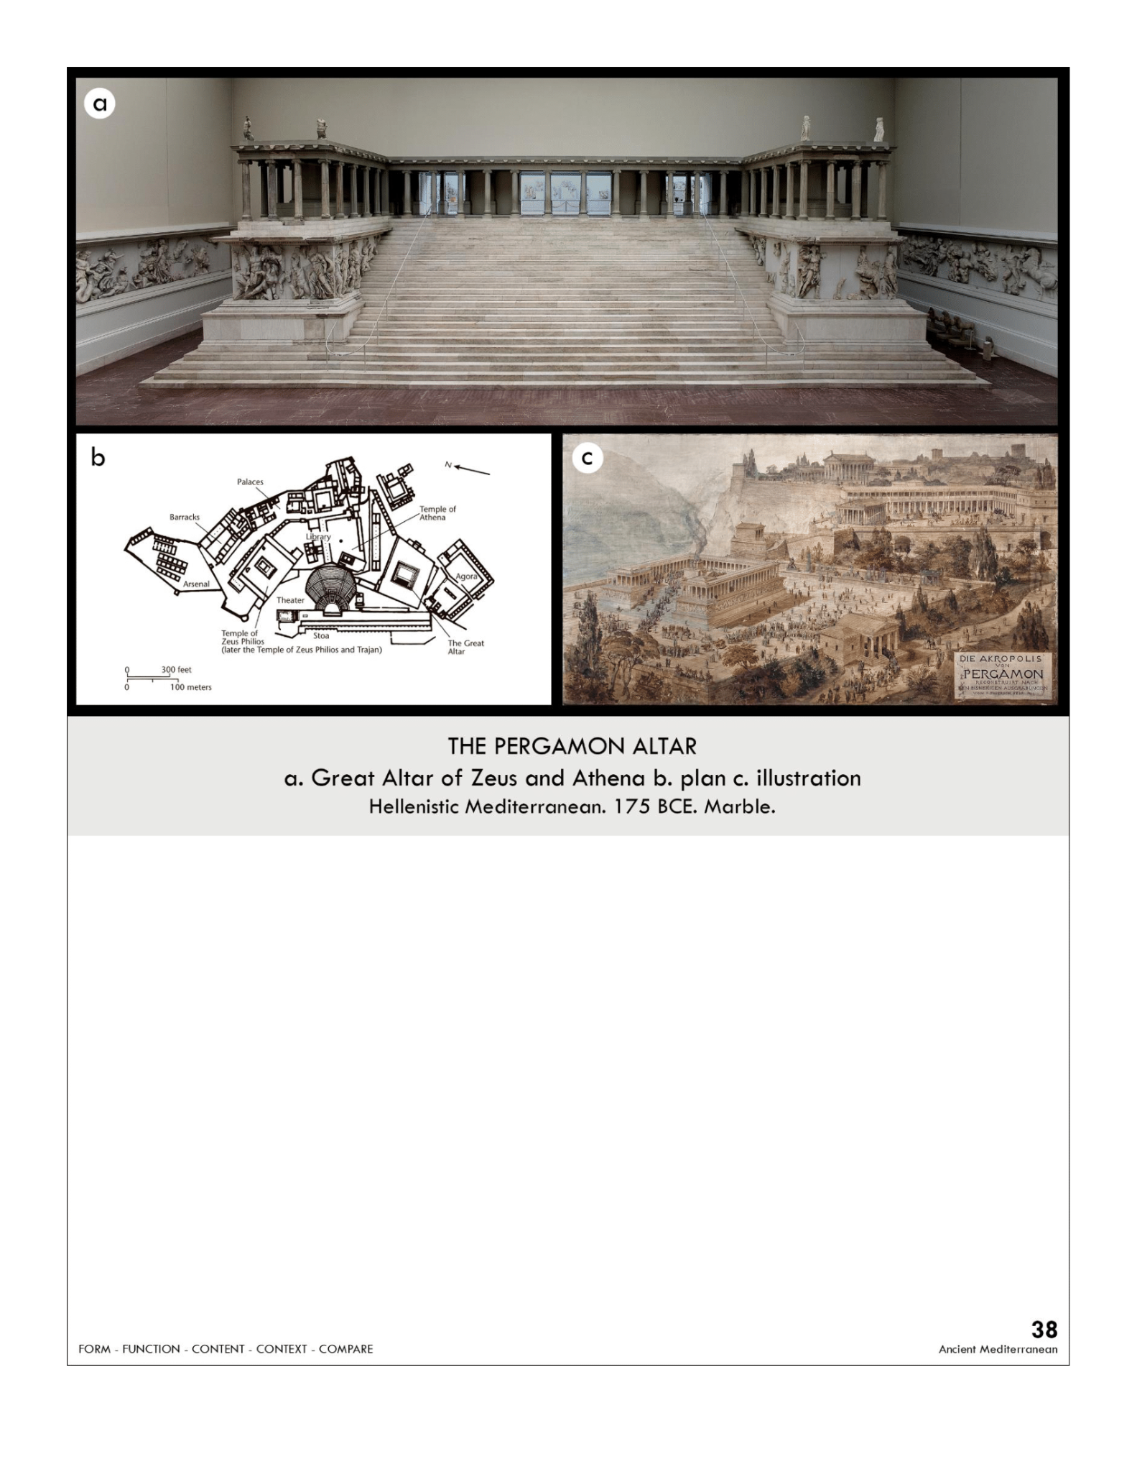

| **Form:**  have altered, around the sides in bas- relief sculpture  High relief sculpture creates great drama, shadow, contrast  More prominent gods and figures are in higher relief  **Function:**  the decoration of an altar dedicated to Zeus- religion, and myth telling, Gigantic sacrificial altar to Zeus  **Content:**  The altar around the sides shows A battle of the Greek mythological pantheon of gods vs. the Giants to determine the controller of the universe. Athena, over-raw emotion, amplifies humanism, twisting bodies. **Expressive and dramatic more than beauty and calm: Hellenistic sculpture ( late classical)**  **Context:**  Founded by general Alexander The Great, Given control of this area turned into a center of learning(Pergamon). Hellenistic period Greece gained power. In modern-day turkey. Gulls Alexander the Great ``Hellenized," or spread Greek influence, from Egypt to the Indus Valley during his reign. When Alexander the Great died, his four generals inherited his land and reign.  **Compare:**  **38**  Ancient Mediterranean |
| --- |

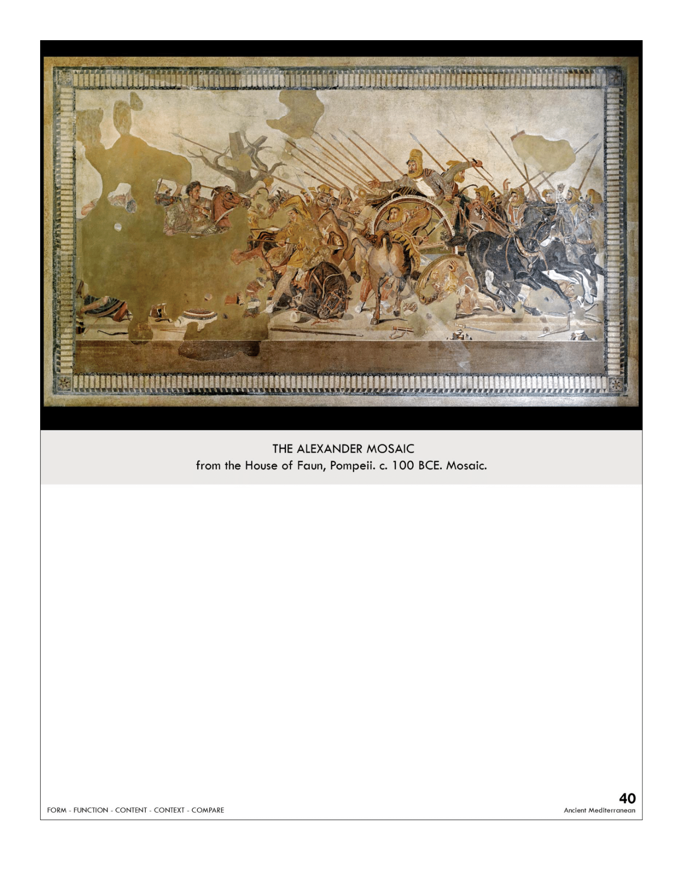

| **Form:**  glazed terracotta stones: tesserae mosaic, placed stones to create images. Floor possibly based on a wall painting done in 315 B.C.E., Hellenistic Period by a greek artist  **Function:**  history painting, tells a story of an event from the past, for a political event, decoration of a home. found in the House of Faun which was the nicest mansion found in Pompeii.  **Content:**  reflection in painting, an indication of shadow, done in 3 dimensions, overlapping figures  a very dramatic and chaotic scene with a sense of momentum as the massive chariot is turning around  Darius is turning his army around, his face with a desperate and, emotional quality, his hand extended in horror of his guard who has just been speared in front of him  **Context:**  Shows battle of Issus, Alexander is fighting Darius of Persia had finally cornered him and killed him  the Battle of Issus (333 BC) was a turning point in ancient history because the ruler of Persia (Darius III) is ordering a retreat of his troops  Show roman appreciation of greek art  **Compare:**  **40**  Ancient Mediterranean |
| --- |

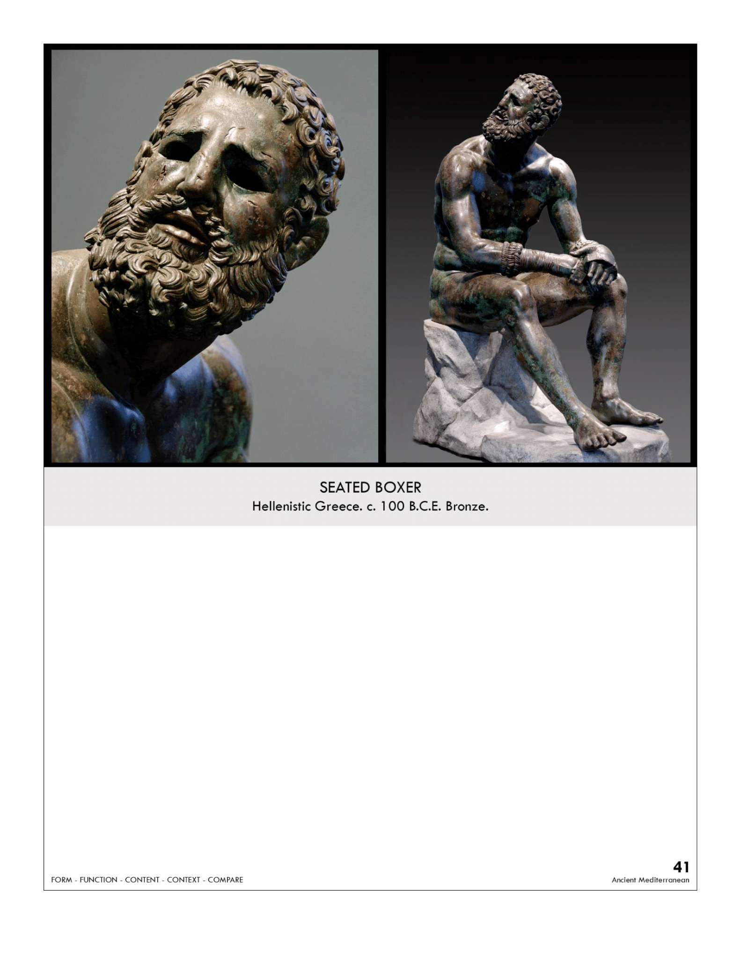

| **Form**: bronze cast ( expensive medel) and very rare. Wax casting different sections welded together  **Function**: decoration for a private home( not entirely sure) shows cultural shift of the hellinestic period. Votive statue?  **Content**:  made out of clay then cast, very realistic art, ugly: broken nose, looks sad. Boxing gloves, blood coming from head wound. Wistfulness and realism. Humanity found in the work. Shows contrast between body, face and hands . sitting with his torso collapsing inwards and his head down, the look of defeat on his face is supplemented by this worn down posture. Hellenistic period.  **Context**: bronze was the ideal to make sculptures of but not many left because they were meant town  During this time Greek art was expanded to include a variety of art. Breaking away from the traditional idealized, heroic, male nude  **Compare:**  **41**  Ancient Mediterranean |
| --- |

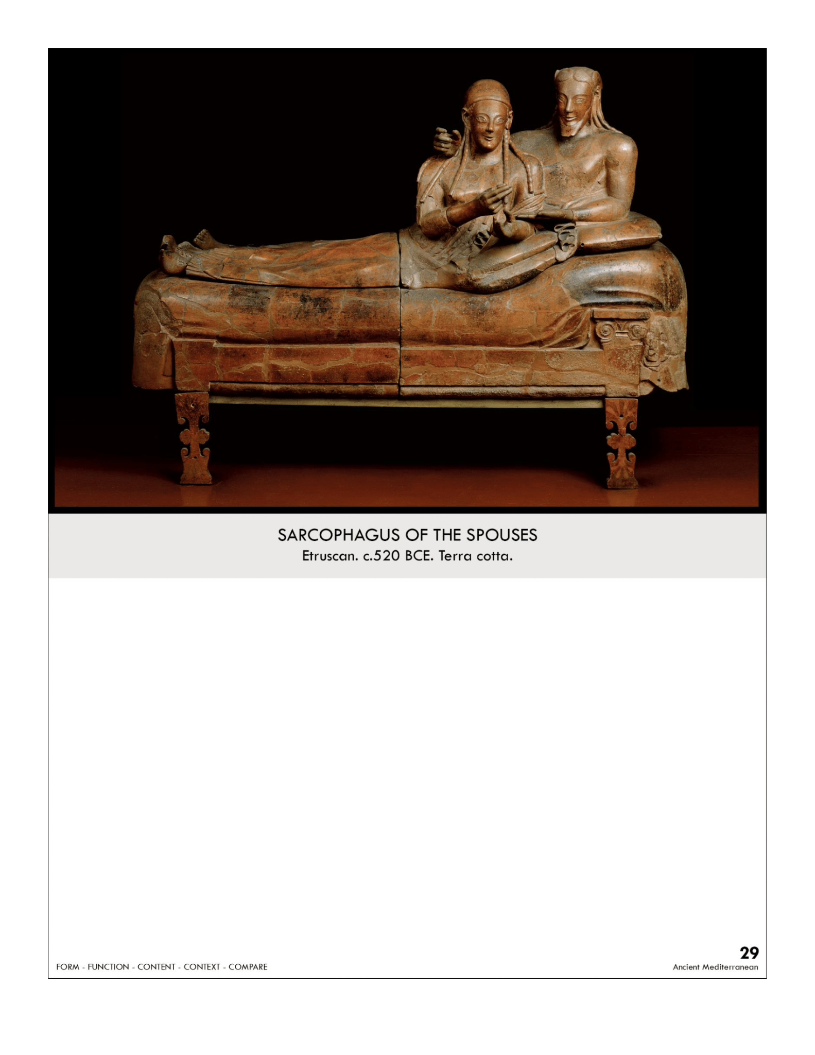

| **Form**: Painted terra cotta, clay, fired in 4 pieces. The sophistication of their firing. High-relief Relaxed figure  **Function**: as a sarcophagus/ tomb for people. Displays the importance of the woman in Etruscan culture by displaying the woman with her husband  **Content:** shows the couple that is buried inside it... She is feeding her husband: egg: a symbol of eternal life. Bending at the waist at 90 degrees CREEPY AF. creates a sense of intimacy  Both are seemingly reaching out, creating depth and a 360-degree work of art  **Context:** the joy of the afterlife and the joy of living. The men and women were equal, women had status ( egalitarian) showing eating while lying down. Found in an Etruscan tomb in a necropolis, Banditaccia at Cerveteri. This is considered the most important work ever found in one of these tombs. The only history of the Etruscans being the art and the inscriptions that came with them  **Compare:**  **29**  Ancient Mediterranean |
| --- |

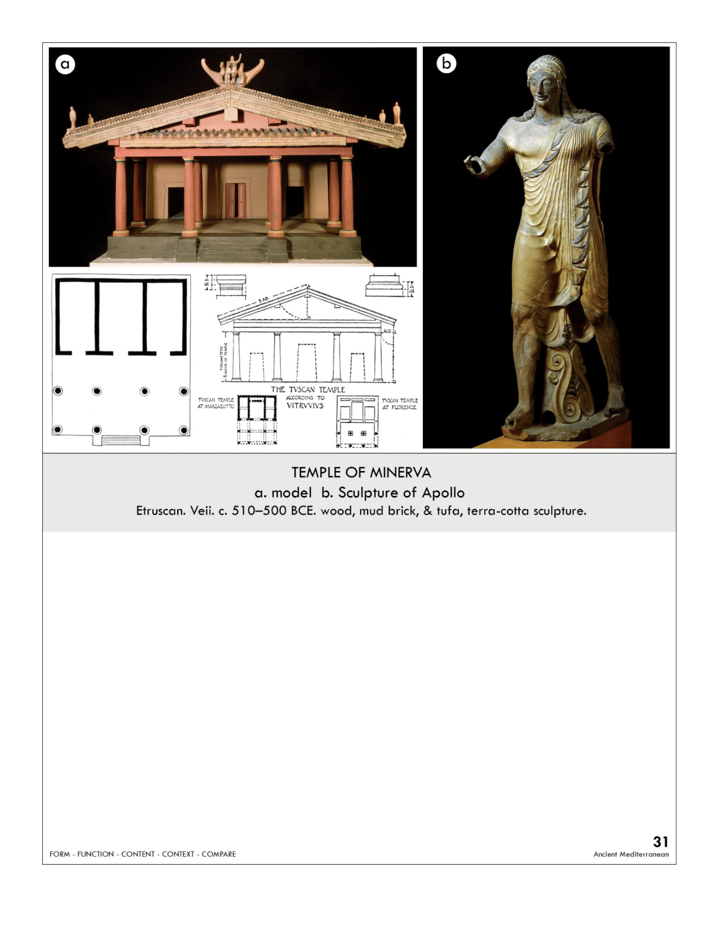

| **Form:** temple had 3 rooms. Doric columns  **Function:** to worship temples to gods/ goddesses. Dedicated to Minerva(Athena). Demonstrates Etruscan assimilation of Greek gods  **Content:**  similar to Greek temples, similar to doric order, different only has stairs up the front not the side, both have pediments, unlike greek don’t have sculptures in pediment. Have 3 different rooms for worshipping 3 different gods/goddesses: cellas Placed on temple not pediment: sculpture  Archaic sculpture: compare to greek statue: has an archaic smile to similarity: different: made out of color it has movement  **Context:**  Same gods and goddesses as greeks, no Etruscan temple has survived Vitruvius was architecture historian wrote about them  **Compare:**  **31**  Ancient Mediterranean |
| --- |

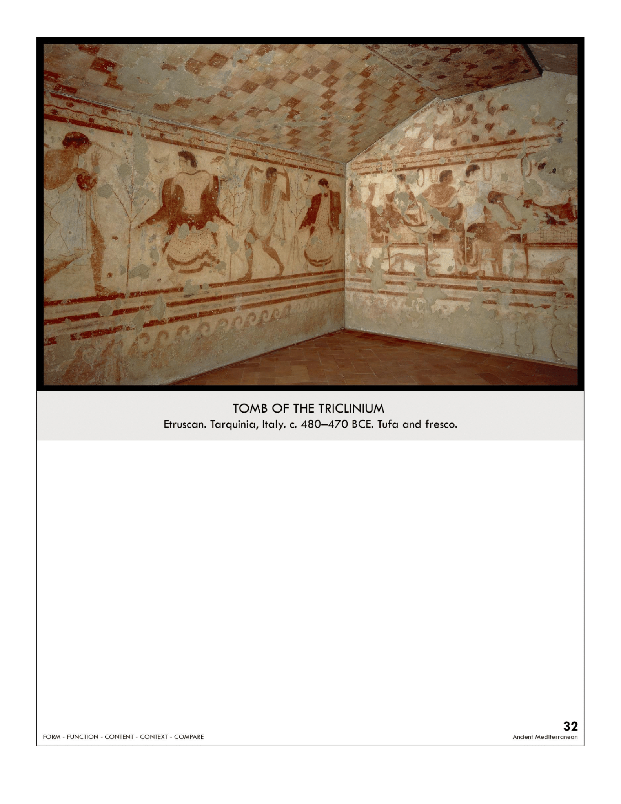

| **Form:** painting . Chamber tombs = subterranean rock-cut chambers  stylistic comparisons between banquet scene and 5th century B.C.E. Attic pottery from Greece  figures are angular and stiff  **Function:** might have been for funerary rituals contain remains of the deceased and various grave goods or offerings  **Content:** shows people dining and dancing, shows women white and men with darker skin. Abstract checkerboard pattern on the ceiling.  single chamber with wall decorations painted in fresco  Chamber tombs = subterranean rock-cut chambers , accessed by an approach way --> dromos  **Context:** expressing death and eternity in the death of Etruscans. Etruscan culture = advanced Iron Age culture  wealth based on Italy’s natural resources -- metal and mineral ores   * Etruscans believed that their lives in the afterlife would be very similar to their life on earth, kind of like Egyptians * funerary customs: Etruscans did not bury their dead inside city limits, but still sought to provide peace and comfort   **Compare:** Egyptian tomb painting tomb of Nebamun  **32**  Ancient Mediterranean |
| --- |

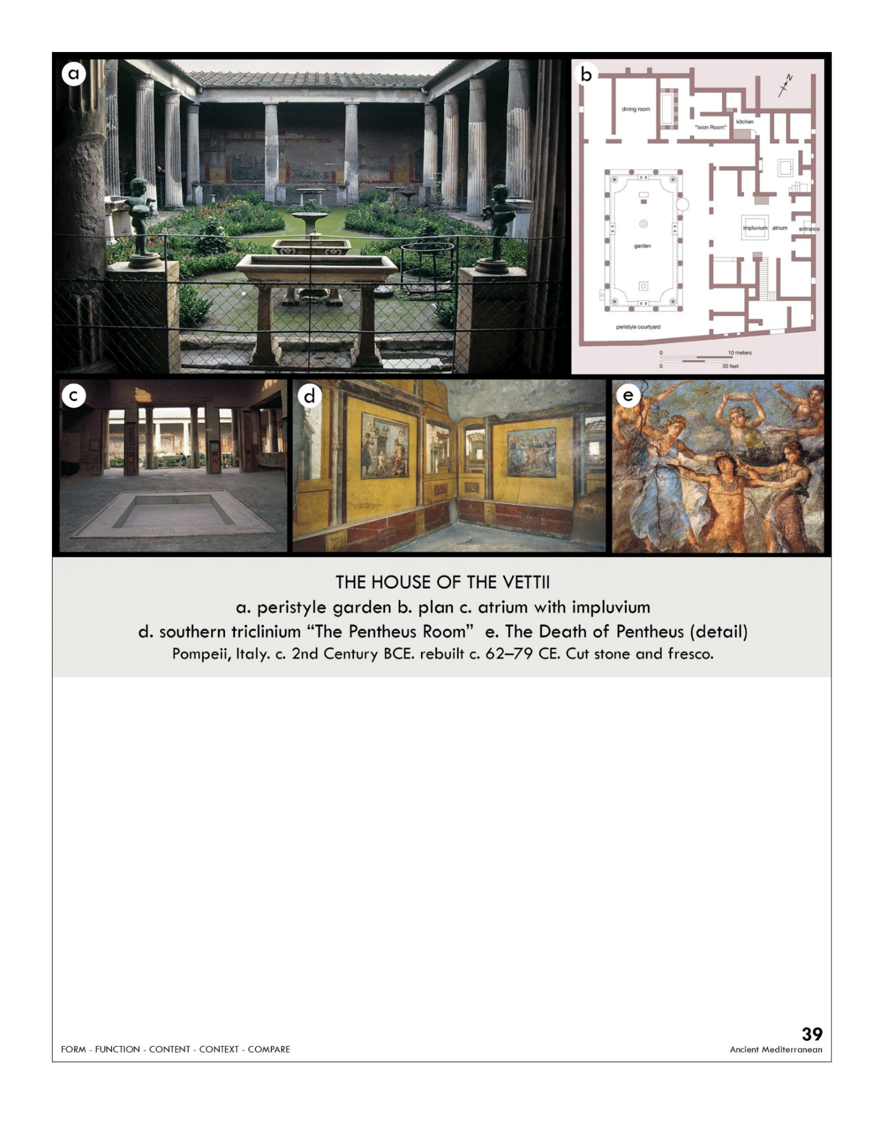

| **Form:** Covers 1,100 sq. meters, Demonstrates Pompeii's late artistic and architectural styles, frescos, on was walls/ on plaster  **Function:** Roman house owned by 2 brothers and their families. To display the wealth and status (albeit newly gained) of the brothers Vettii  **Content**: Had an impluvium which was used as a pool and for water that was collected by rain. peristyle garden: columns all around it. Sculptures in gardens, private gardens inside houses.Pentheus room: paintings; painting of Hercules cast shadows, perspective, Pentheus painting. The painting shows depiction of  **Context:** Many wealthy families of Pompeii fled to other Roman cities after the Earthquake of Pompeii in 62 CE. Conviva and Restitutus were both freedmen, new to wealth and status.  House owned by Aulus Vettius Conviva and his brother, Aulus Vettius Restitutus. Conviva was an Augusta lies, a position of the highest civic office a freedman could attain.  **Compare:**  **39**  Ancient Mediterranean |
| --- |

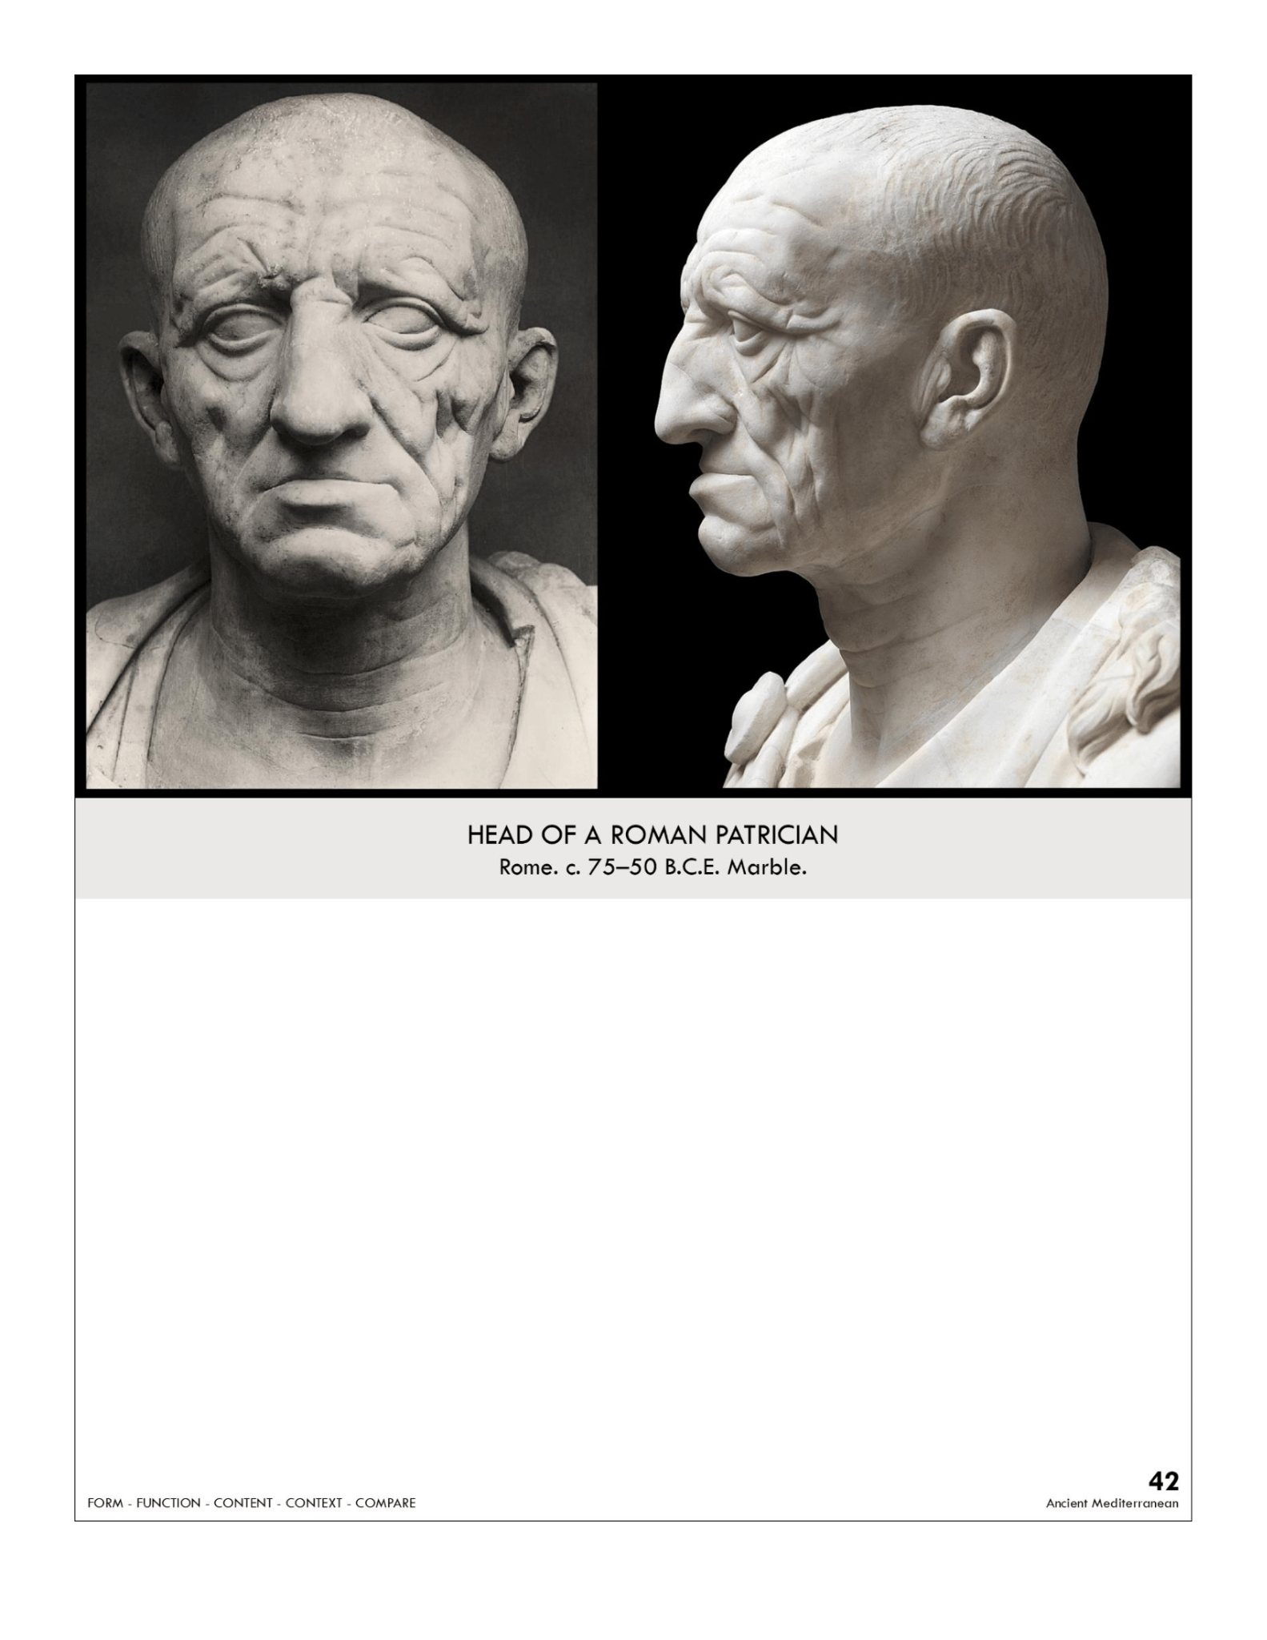

| **Form:** carved marble and life sized. Polychromed (painted in several colors)   * *Terra Cotta*- was used and then painted with encaustic (otherwise referred to as a hot wax process) * Veristic Style: Verism * A form of realism (hyper-realistic) Over exaggerated (extremely aged and careworn)   **Function:** A portrait to be remembered, to be remembered and displayed/kept in the home. A **veristic** sculpture that accurately depicts a patrician  **Content:** very realistic, ugly, realism ( many ways the very first) wrinkly, balding, wearing fancy toga, stern expression, not idealized  **Context:** unknown artist who works professionally as sculptures. People would go to these places to get their sculptures made, in the republic period of rome. mostly preferred than men then and most sculptures are of men . partition( member of the senet, can vote wealthy family) — Start of 200 B.C. individuality was increasing  **Compare:**  **42**  Ancient Mediterranean |
| --- |

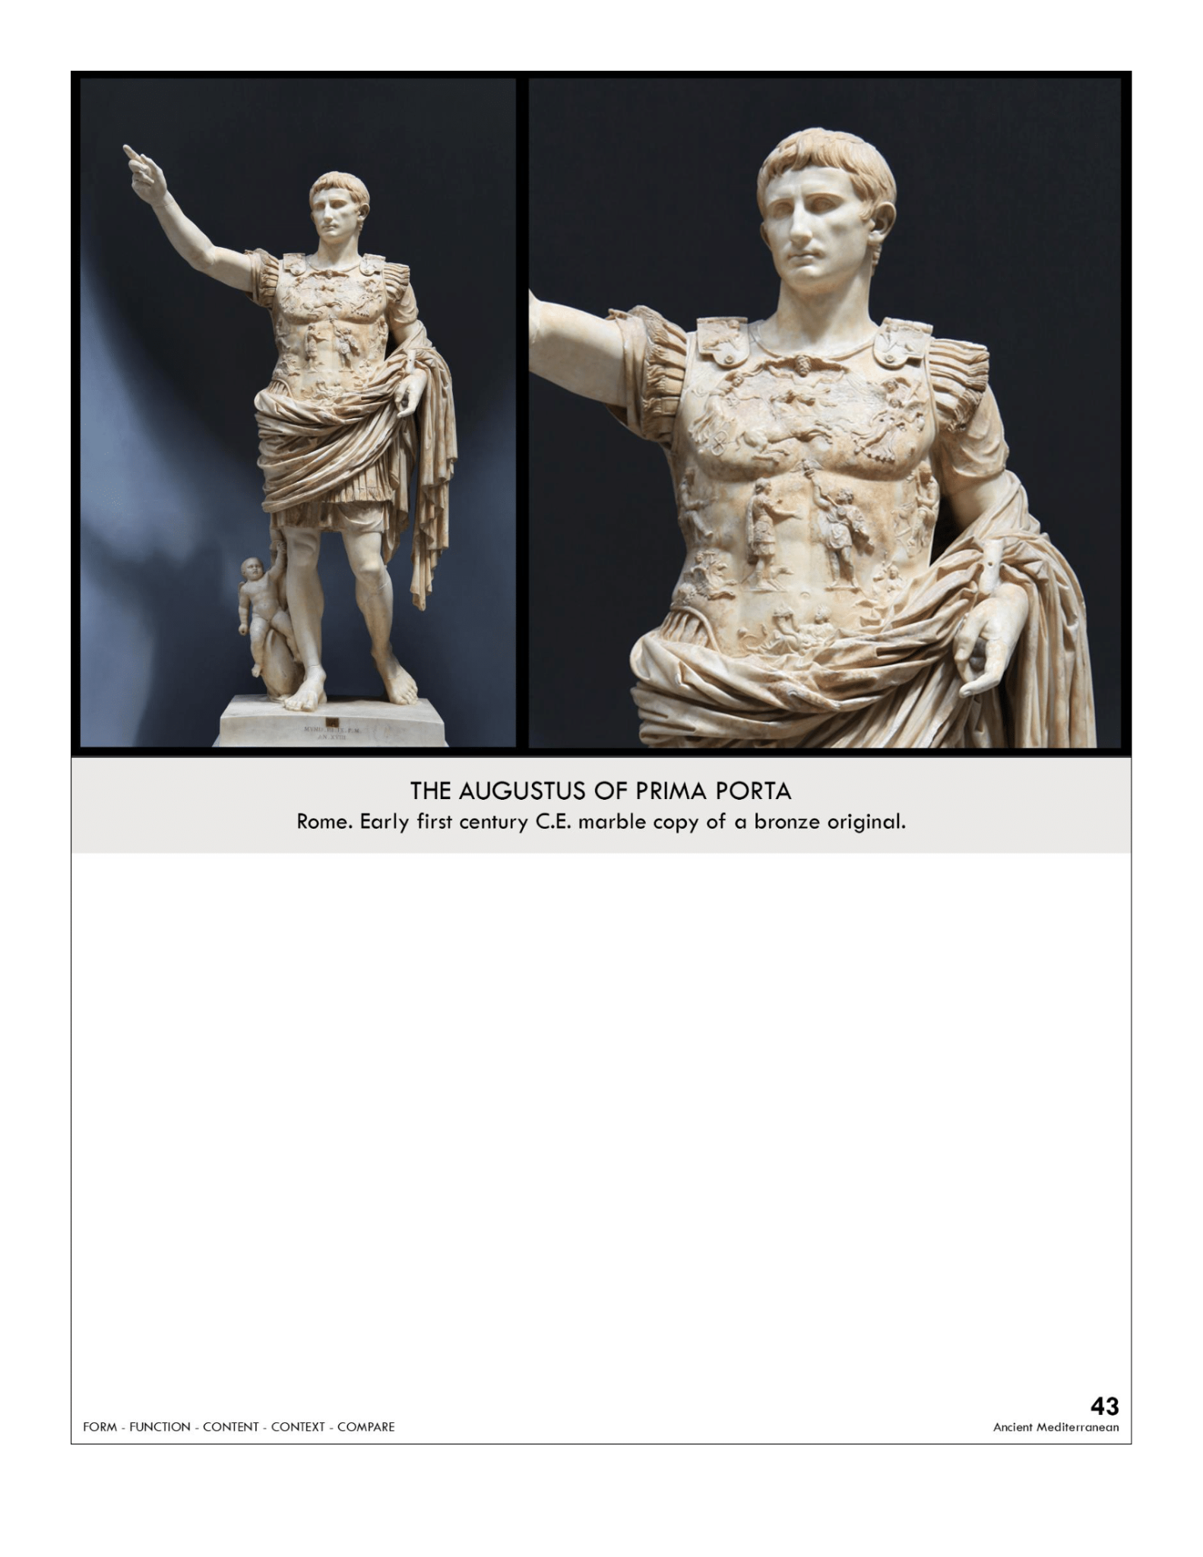

| **Form:** Marble over life-sized  **Function:**  public propaganda/celebrate the emperor and his victory over the Parthians  **Content:** has cupid riding a dolphin( purpose face planting into stone)-symbolizes the goddess venus. Shows the connection and lineage of the gods and goddesses, descended from then.. Of great augustus- first emperor of Rome . standing with. Brestpate being handed a roman standard pathinens defeat by romans. Naturalistic movement was once painted. Weight on the right leg and right are pointing up. Youthful beautiful face, intentionally idealized (like greek tradiction). Figure might be goddess roma (breastplate) eagle on top.  **Context:** Very Greek, contrapposto stance. Maybe a copy of the original bronze sculpture 19-20 BCE. Augustus is divinely organized. A Greek revival.  **Compare:** Polykleitos Doryphoros  **43**  Ancient Mediterranean |
| --- |

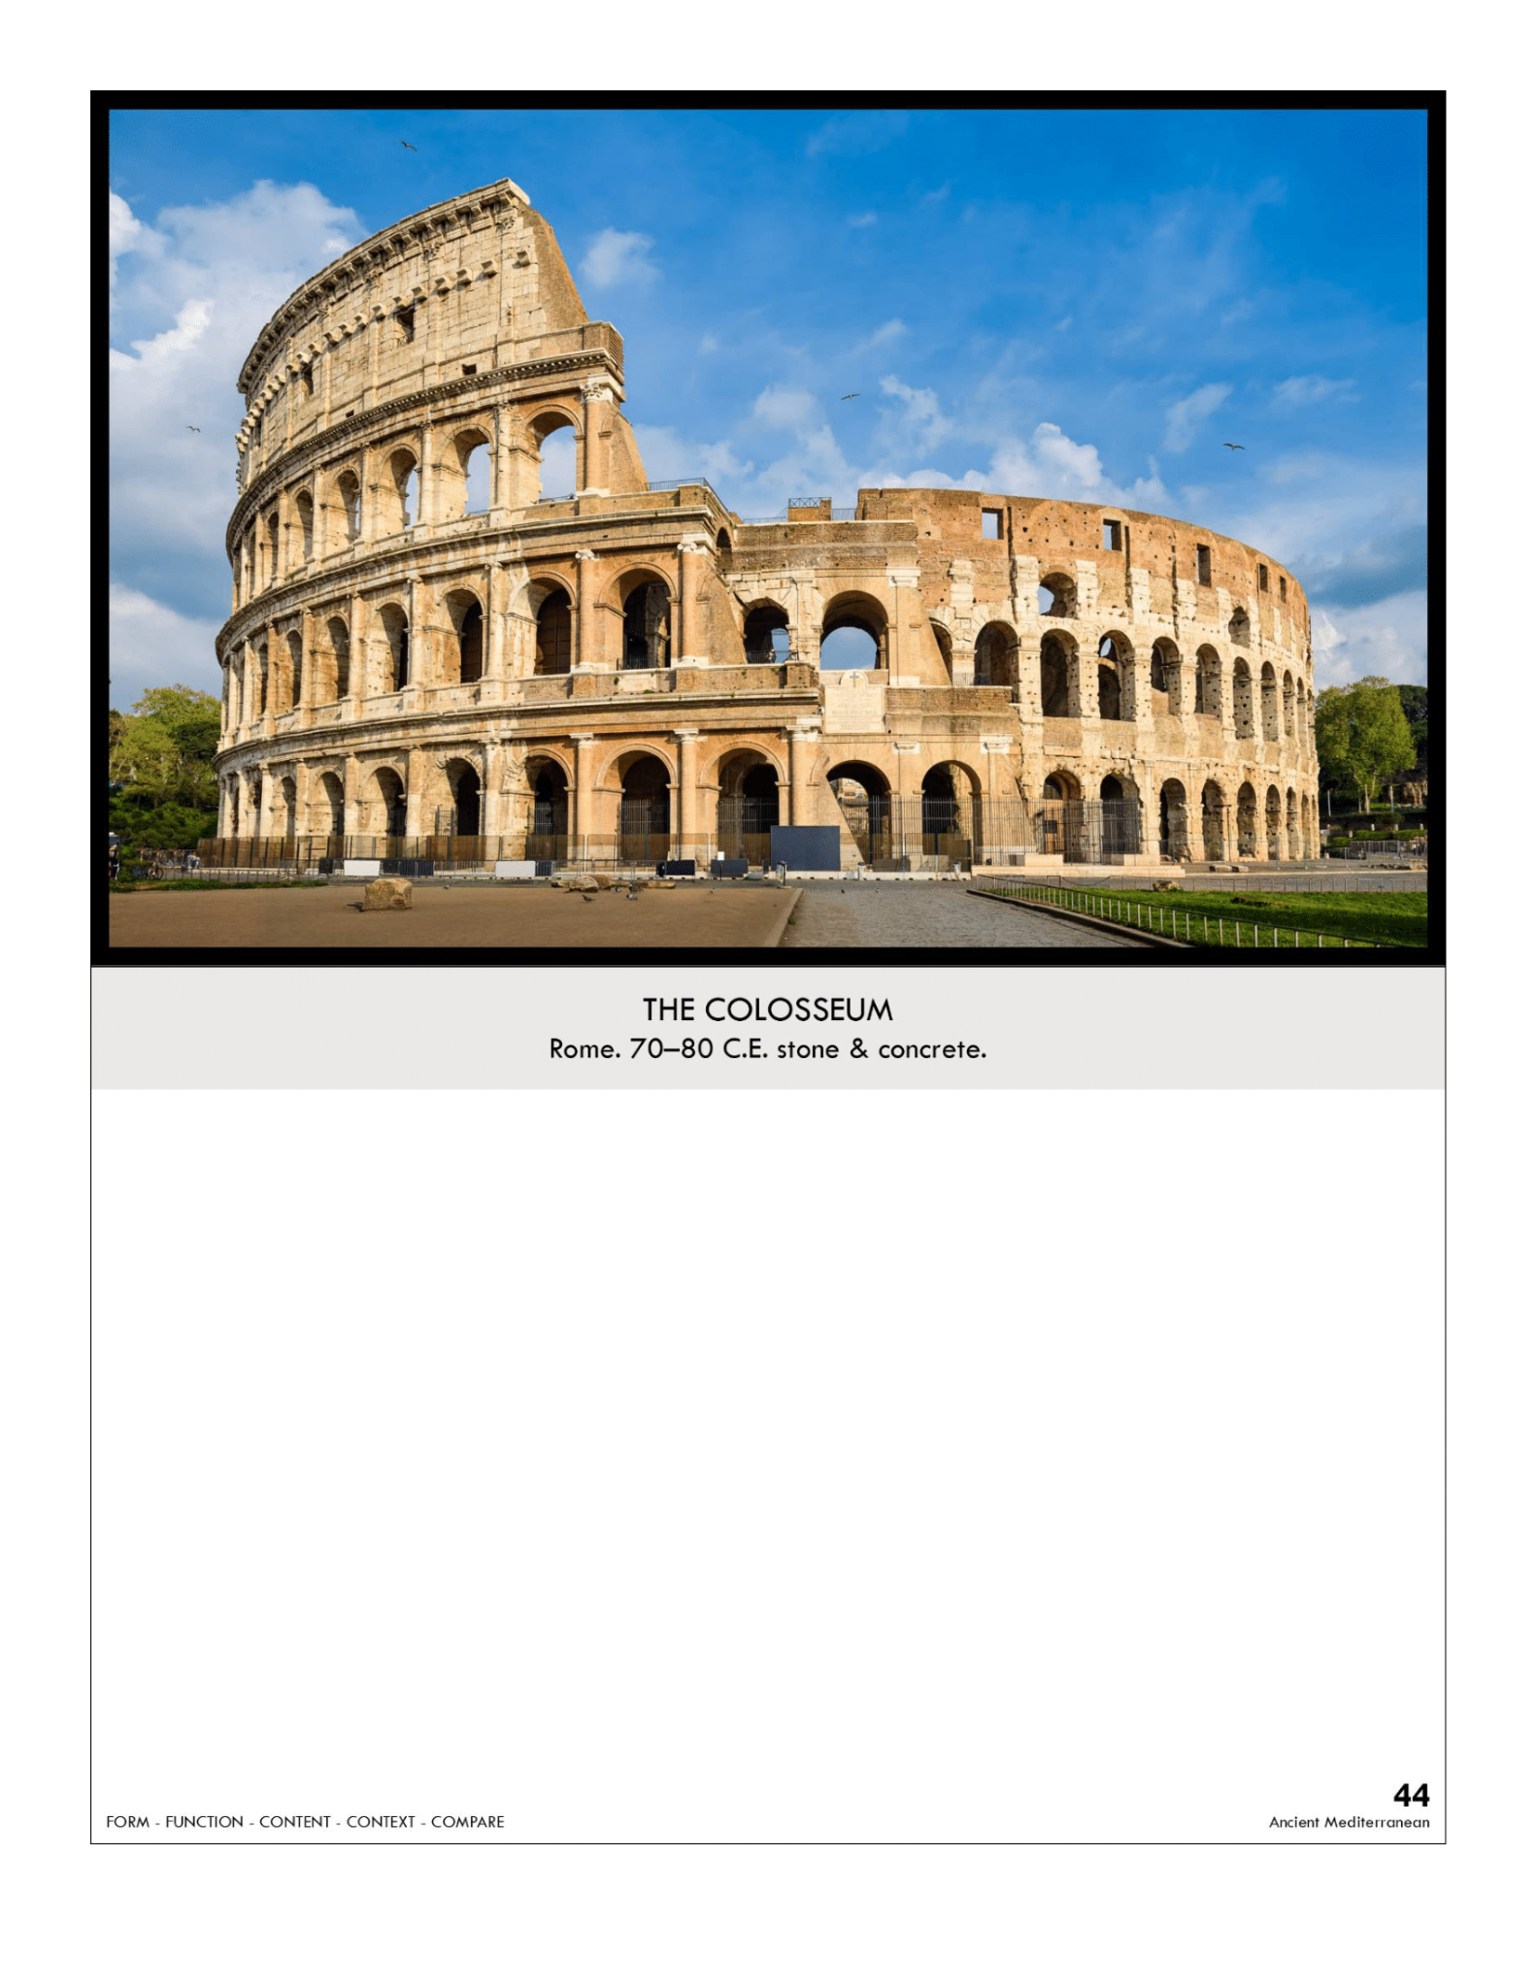

| **Form:**  Largest ever built at its time. Holds 50000 people can be flooded for a naval battle, made of marble .two Greek theaters put together (facing each other) to create the oval-shaped amphitheater (stadium)   * Inner ring made from concrete * Outer ring (external wall) made from travertine (a limestone) * Extensive use of vaults and the Roman arch   **Function:**  sports and game stadium of Rome for gladiator fights, combat, and for spectacle.  **Content:**  built in the imperial capital of rome. Used engaged columns in dornic order 1st level - ionic 2nd- corinthian-3rd. four main levels (can be thought of as registers! above the 4th level, the upper rim of the colosseum was lined with bronze shields/spears  **Context:**  the flavian empire, built over a 10 year period. Became a quarry for other building projects overtime  **Compare:**  **44**  Ancient Mediterranean |
| --- |

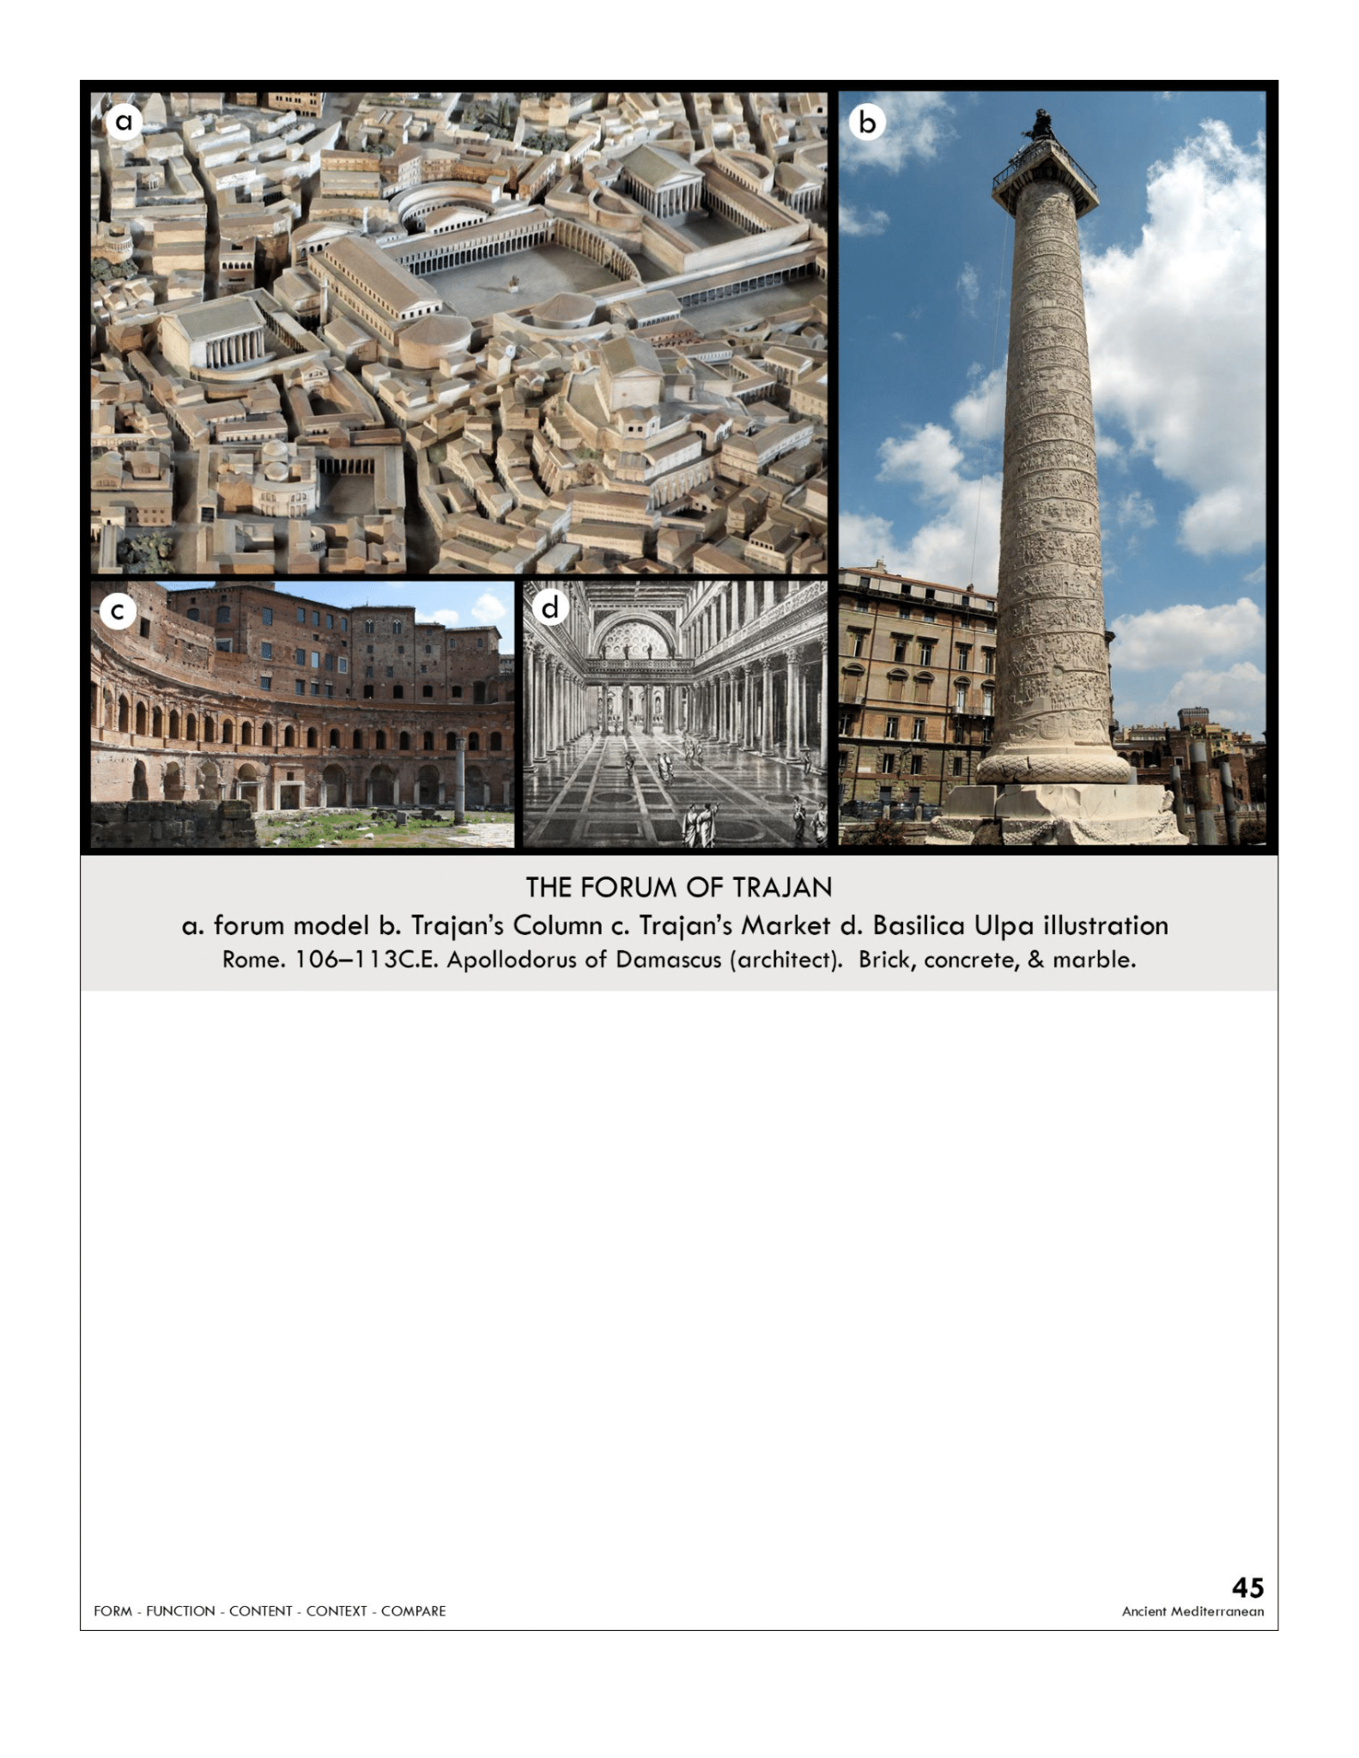

| **Form:**  Made of brick. Column made of marble  **Function:**  Public meeting spot. Civic center  **Content:**  Includes symmetrical interior space called basilica: a place for business transactions markets and legal transactions. Outside of the basilica ulpia a lot is Trajan's column with the story of him defeating them and a statue of him at top. Open-air colored courtyard with first western equestrian statue. The right of the column is the library and to the left is the market. Colinod with Corinthian columns. Was made with cranes and lifting. Sculpt story in spiraling register  **Context:**  Trajan defeated the dicaans and created a new public square: the base of the column is where his and his wife was buried and was dedicated to him. ( senet give the column to him) : the story is very confusing, doing a lot, fighting side: created by emperor Trajan, high period of Rome  **Compare:**  The agora in Athens . Standard of Ur. Bayeux tapestry  **45**  Ancient Mediterranean |
| --- |

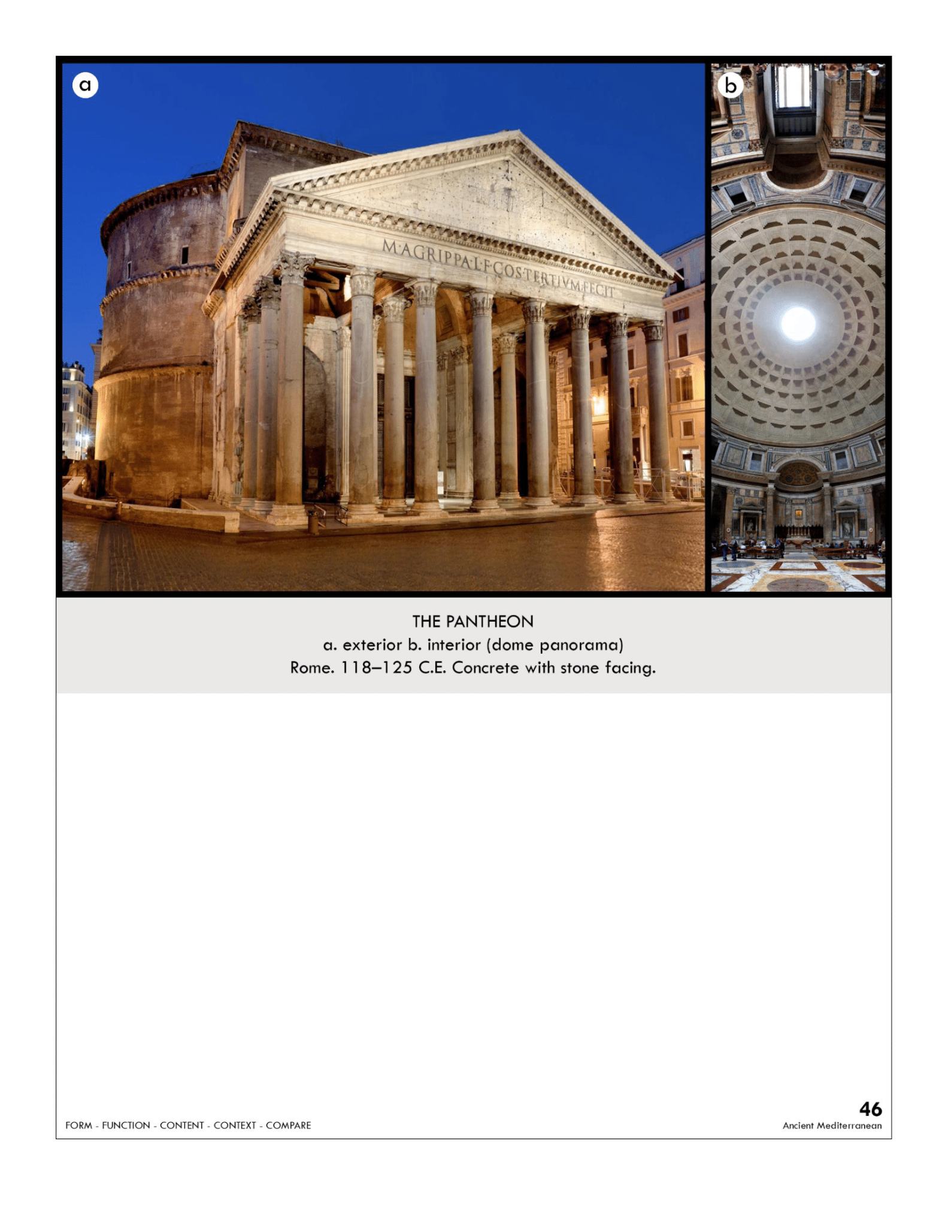

| **Form:** Gigantic drum holding up the dome, perfect sphere. 142 feet high and across, created by an unknown architect  **Function: a** temple dedicated to all gods of the roman empire = pantheon  **Content: the** largest interior dome of the ancient world, corinthian columns. classically-inspired corinthian temple front leads to a cylindrical calm open interior. The composition had lighter stones at the top. The topmost point has an oculus opening to the sky. Thickness decreases  **Context:** each pillar carved out of one piece was made under emperor hentinen and financed by algorithm. Shows use of concrete  **Compare:** and major religious temples. Stark cathedral, anchor m  **46**  Ancient Mediterranean |
| --- |

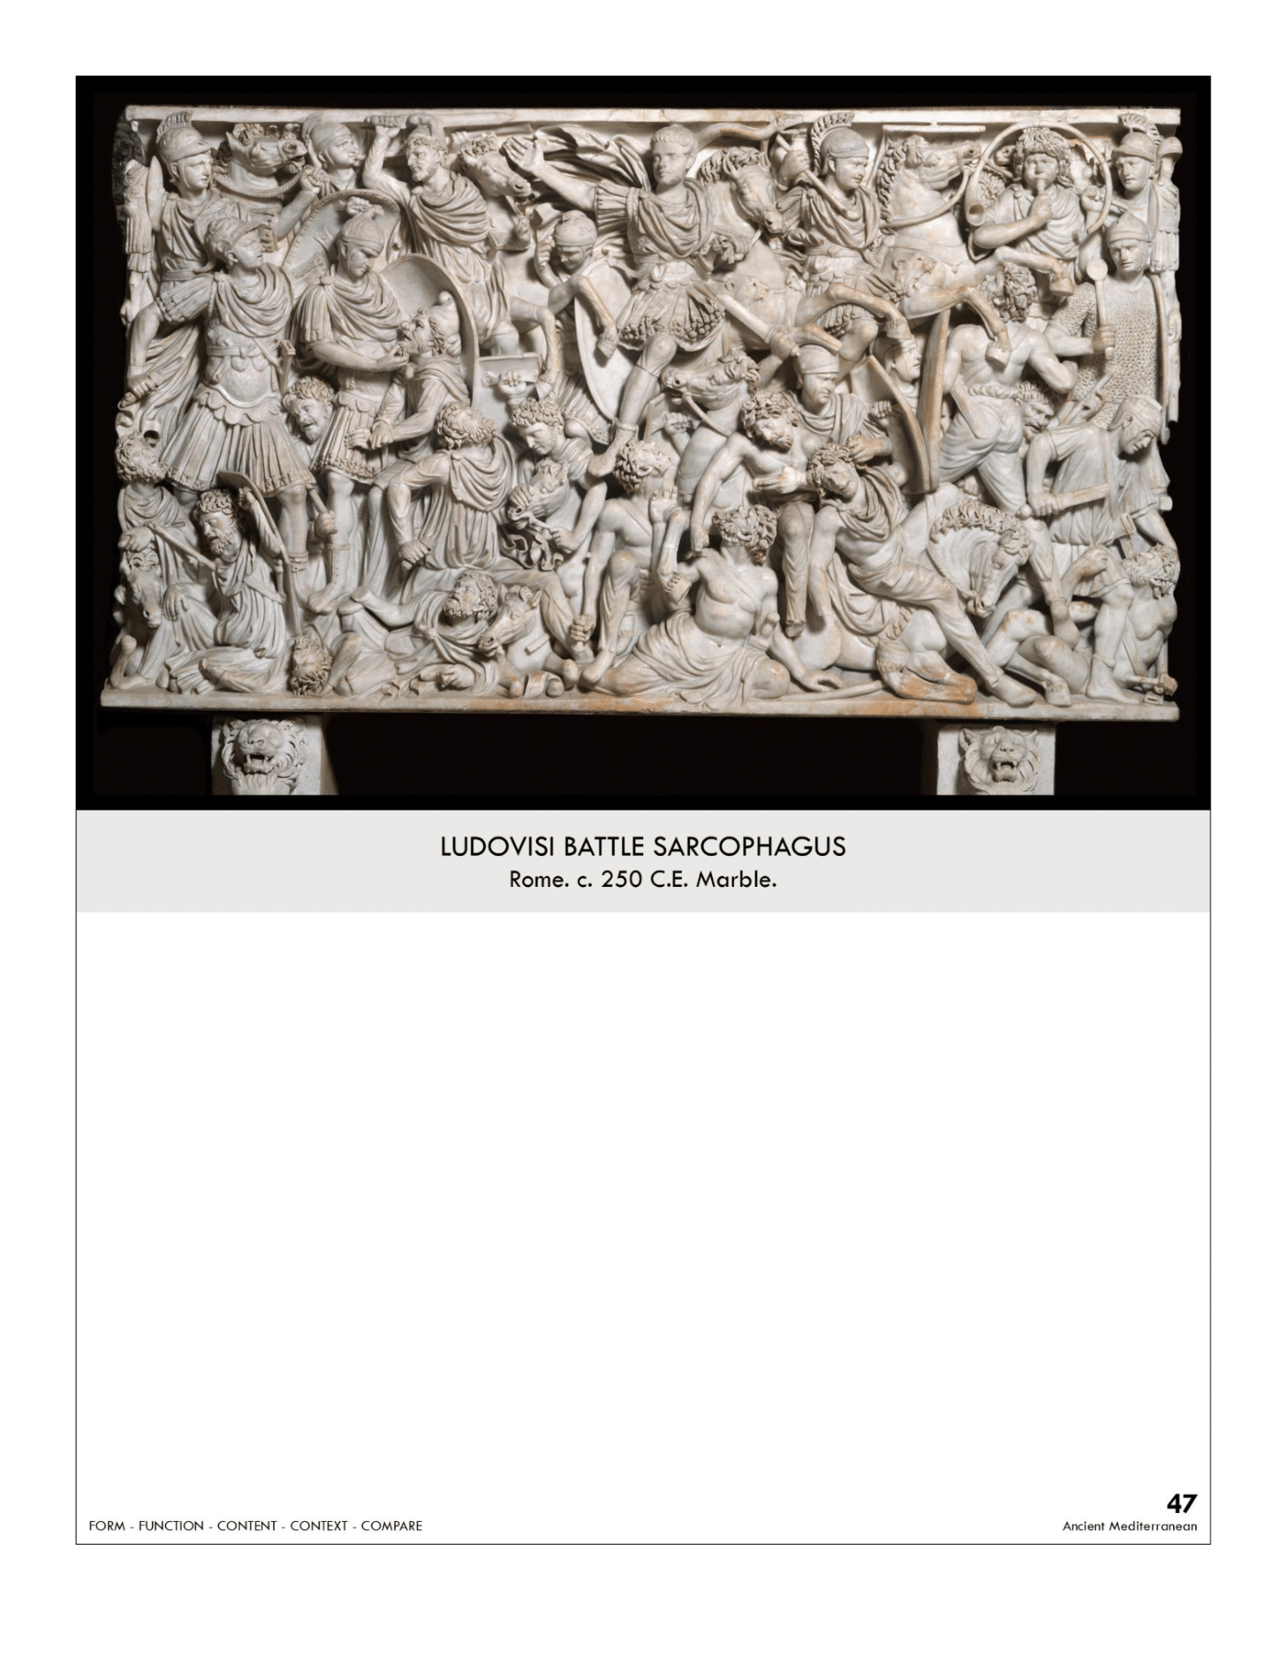

| **Form:** marble carved in a deep relief  **Function:** a sarcophagus used for burial and death  **Content:** Romans have more idealized features and the goths are more ugly and characterized. Very dense and much stacking. At the top is the hero, body splayed out/radiating. Movement, very activated surface. Sense of seriousness. gets smaller towards the bottom and shows an interesting perspective. Chaotic surfaces  **Context:** in the period of the late empire. Clive wars have happened for centuries. In the 2nd century, it became fashionable to bury the dead. Unstable empire, the chaos of surface reflects the chaos of the time  **Compare:**  **47**  Ancient Mediterranean |
| --- |

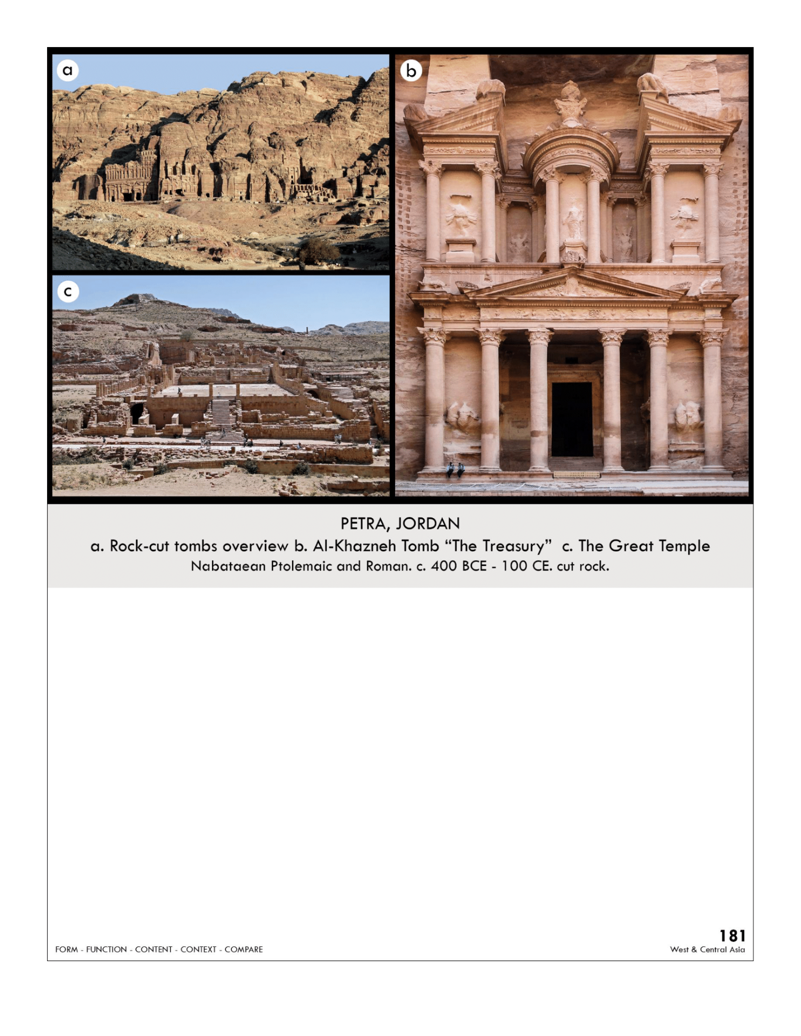

| **Form:** carved out of the mountainside  **Function:** rock-cut tomb for important figures  **Content:** columns are corinthian order with a frieze and pediment with sculpture. It's like 2 temples stacked on top of it. It has a broken pediment on both sides, symmetrical and slic tholos: in the middle is a Greek temple that is round. Called bedrock  **Context:** Petra was the central city of the nabataeans, they came to the city to bury their honored dead. Unesco world heritage site. High empire period of rome. High classical deviation compared to baroque architecture  **Compare:** baroque architecture of borromini : church of 3 fountains  **181**  West & Central Asia |
| --- |